FOR IMMEDIATE RELEASE
Contact: Chelsea Pillsbury
703.740.9496
cpillsbury@thevisioncouncil.org

THE VISION COUNCIL RELEASES Q1 PROVIDER INSIGHTS REPORT
Highlights operations and sentiments of U.S. eyecare providers

Alexandria, VA – June 6, 2023 – Today, The Vision Council released a new research study reporting on operations and sentiments of U.S. eyecare providers. The 2023 first quarter Provider inSights dives deep into how eyecare providers view the current state of their practices, the eyecare industry, and the American economy overall.
"This study demonstrates that American eyecare providers have an optimistic outlook for their businesses in 2023. However, they are experiencing acute pressures from both inflation and labor market shortages" said Alysse Henkel, Senior Director of Market Research and Analytics at The Vision Council. “Overall, this report shows that eyecare providers remain confident in their ability to meet revenue goals, acquire and retain patients, and continue to provide quality eyecare to people everywhere.”

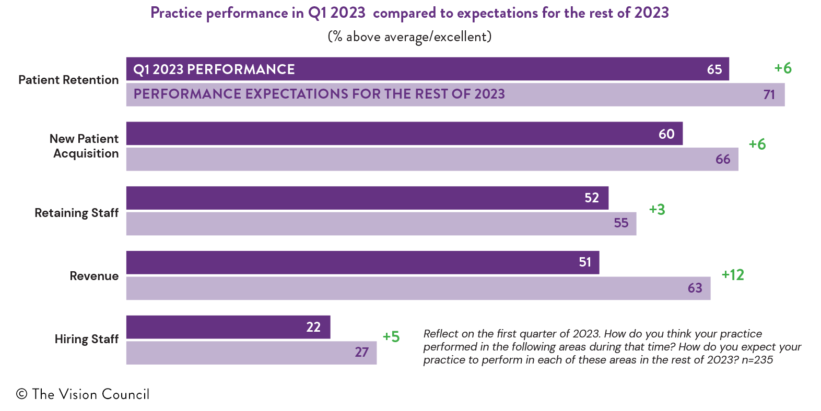
Key findings from the report showed that economic concerns including increased wholesale prices of eyewear products and practice supplies were some of the biggest challenges for eyecare providers. Eyecare providers also reported that patients are more price-sensitive when choosing eyewear.

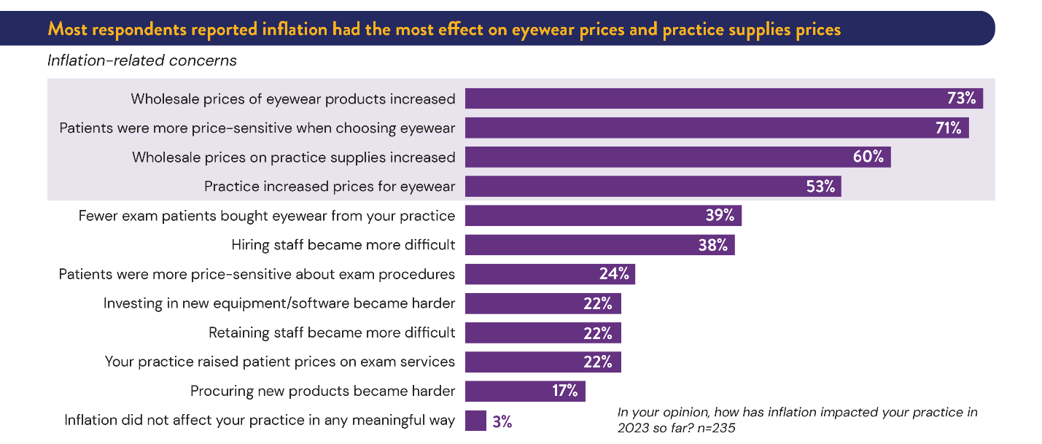

Additional report highlights:
- Most eyecare providers said they increased prices for eyewear due to corresponding wholesale price increases.
- Slightly more than half of practice owners did not make or do not plan to make any major investments in their businesses in 2023.
- Most eyecare providers reported that telehealth services are not a priority for their practices.

The full report is available in The Vision Council’s Research Download Center as a complimentary download for members of The Vision Council, with a paid option for non-members to download.

More about the inSights Research Program

The Vision Council’s inSights Research Program launched in May 2022 and is built on a foundation of rigorous methodology and cutting-edge technology. The inSights Research Program provides a comprehensive perspective on the state of the optical industry through quarterly consumer survey reports; quarterly in-depth special reports on eyewear and eyecare products and topics; and an end-of-year market estimate and industry forecast.

Upcoming inSights Research Reports include 2023 Focused inSights: Sunglasses Snapshot, which will be released in June, and an updated Market inSights report will be released later this summer.
# # #
About The Vision Council

The Vision Council brings the power of sight to all through education, government relations, research, and technical standards. A leading advocate for the optical industry, the association positions its members to deliver the eyewear and eyecare people need to look and feel their best. Vital to health, independence and safety, better vision leads to better lives.

